Restore SealUS

Backups
\\tuna\d$\DataSSWDataSealUSBackup

Procedure
- Install windows 2003 standard edition
- Setup IP addresses
  - IP
    - 66.246.252.18 – 255.255.255.224
    - 66.29.18.65 – 255.255.255.248
    - 66.29.18.66 – 255.255.255.248
    - 66.29.18.67 – 255.255.255.248
    - 66.29.18.68 – 255.255.255.248
    - 66.29.18.69 – 255.255.255.248
    - 66.29.18.70 – 255.255.255.248
  - Gateway
    - 66.246.252.1
  - DNS
    - 207.99.0.1
    - 207.99.0.2
- Install IIS
- Make sure all latest drivers are used
- Install all service packs and updates
- Install latest version of Office.
- Office 2003 Update: Redistributable Primary Interop Assemblies
  - http://www.microsoft.com/downloads/details.aspx?familyid=3C9A983A-AC14-4125-8BA0-D36D67E0F4AD&displaylang=en
- Install SQL 2005 – Instance Name: SQL2005
  - Service Packs
  - Only allow connections on remote IP
- Install Serv-U FTP 6.2
- Install Plesk 7.5.6
  - Login to control panel
    - U: admin
    - P: setup
  - Use licence certificate – Cant work out how
- Restore Plesk Backup
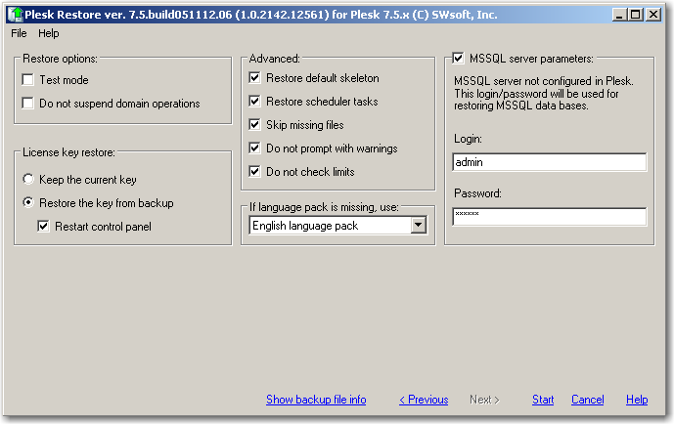
- Restore SQL Backups
  - If you cannot load the plesk admin page then run the “Plesk Reconfigurator” and run the “Check & Repair”
- Setup SQL Replication
  - SSWData2005 – FTP Rep
  - Asnewprint – HTTP Rep
- Install Certificates on the server for SSL
- Install Access Reporter
  - Setup for SSW Website
- Setup SQL fro ASP.NET
  - aspnet_regsql.exe
  - Open up C:\WINDOWS\Microsoft.NET\Framework\v2.0.50727\CONFIG\machine.config and change the default LocalSqlServer connection string to .\SQL2005
- Specify the machine key for .NET
  - C:\WINDOWS\Microsoft.NET\Framework\v2.0.50727\CONFIG\machine.config
  - <machineKey validationKey='E437FEACEF0C3B6846F197A06347D2C2C240089E8A88D27545AD63F00AC61E47D5122C20CD386C3FAA4C21954E6C34642DB6F69A39941E0C0F4853D998A09E70' decryptionKey='8795CB051770075258AA6ADF1DBF975C320C5F5AD3495017' validation='SHA1'/>
  - Once you have made that change test by going to a website that does a post back. (e.g. a login page)

- Install 3rd Party Software
  - 3Ware Raid email notification
  - ISAPI_Rewrite - http://www.helicontech.com/download/#isapi_rewrite

